Table of Contents:

Game Mechanics …………………………………………………………………………………………………. Page 2

Controls …..………………………………………………………………………………………………………… Page 3

Gameplay Screen ………………………………………………………………………………………………… Page 4

Saving and Loading ………………………………………………………………………………………………. Page 5

Game Mechanics:

Goal of the Game:

* Kill enemies and collect orbs to transform and level up your ship and get to the farthest wave you can!

Transforming:

* Once the player collects enough of a single type of orb, they can temporarily use those orbs to transform into the corresponding form.

Experience:

* Each kill counts as experience towards current form of the player. Once a player gains enough experience their ship will level up resulting in a stat boost.

Upgrade Your Ship:

* After each wave the player has a chance to upgrade their ship through purchases using orbs collected during the waves.

Controls:

Navigation of Menus:

* The menus can be navigated using the arrow keys or the mouse. Highlight the desired selection and press Enter.

Flying the ship:

-The arrow keys can be used to control the ship during gameplay.

Transforming:

* When transformation forms are available pressing the corresponding number button will activate the form:
  + Number 1 key: Fire
  + Number 2 key: Lightning
  + Number 3 key: Wind

Game Screen:

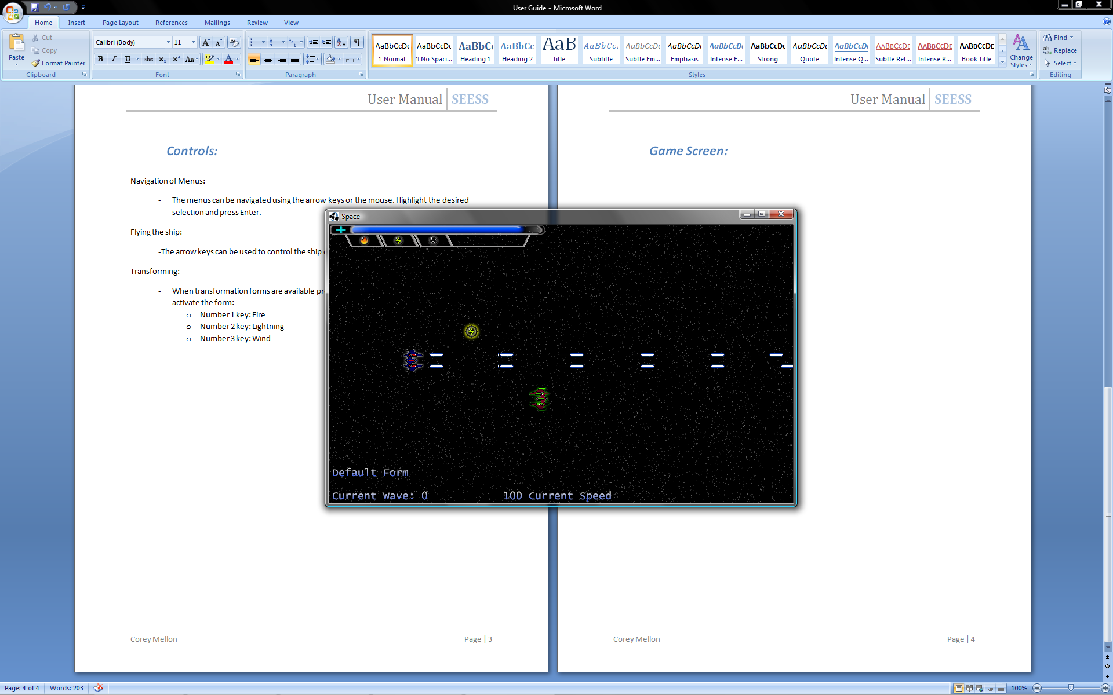

1)HUD- Health Bar

2)HUD- Form Enabled Indicator

3)HUD- Form Time Remaining Bar

4)Player

5)Orb

6)Enemy

7)Wave and Form HUD

Saving and Loading:

Saving:

* The player can save their game by choosing the save game button on the upgrade screens.
* In order for the program to be able to save the parent directory of the jar file must be editable.

Loading:

* The player can load their game simply by choosing the load game button on the main menu screen.
* In order to load the save game, the save game txt file must be located in the parent directory of the jar file.